Indeed Documentation

Step 1: Enter cmd and press Enter

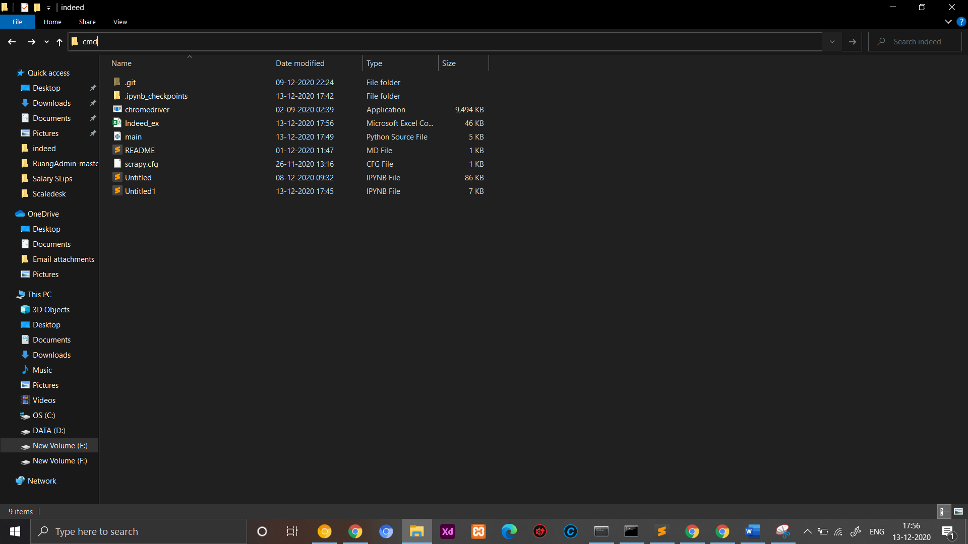

Step 2: If you want to change the link you have to change this path.

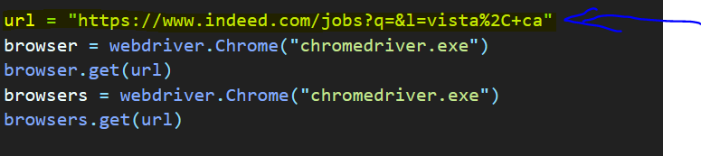

Step 3: For testing purposes you can change this code and type “5”. So, it will scan only 5 pages for testing otherwise it will scan minimum of 66 pages.

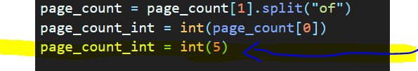

If you don’t want to test remove this line.

Step 4: If u want to change the name of csv file you can change here.

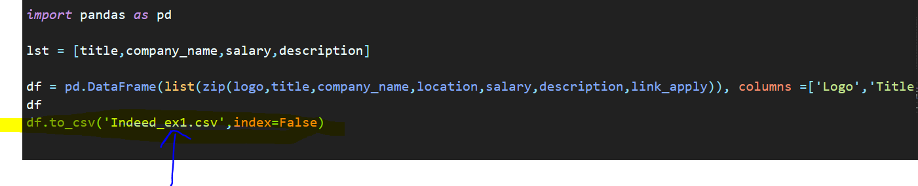

Step 5: Type python main.py in command Prompt and run it will run